Exp No:9a Simulation of Ground Wave and Sky Wave Propagation using MATLAB

Code:
clc;
clear;
close all;

%% Experiment 9a: Ground Wave and Sky Wave Propagation

%% Objective 1: Ground Wave Propagation
Pt = 10; % Transmitted Power (kW)
d = 1:1:500; % Distance (km)

% Ground Wave Electric Field Strength
E_ground = (300*sqrt(Pt))./d;

%% Objective 2: Sky Wave Propagation
h = 250; % Ionosphere Height (km)
theta = 60; % Angle of Incidence (degrees)
fc = 5; % Critical Frequency (MHz)

% Skip Distance
Skip_Distance = 2*h*tand(theta);

% Maximum Usable Frequency (MUF)
MUF = fc*sec(deg2rad(theta));

%% Objective 3: Comparative Analysis
Sky_Range = Skip_Distance*ones(size(d));

%% Display Results
fprintf('\nGROUND WAVE AND SKY WAVE ANALYSIS\n');
fprintf('---------------------------------\n');
fprintf('Transmitted Power = %.2f kW\n', Pt);
fprintf('Ionospheric Height = %.2f km\n', h);
fprintf('Skip Distance = %.2f km\n', Skip_Distance);
fprintf('Maximum Usable Frequency (MUF) = %.2f MHz\n', MUF);

%% Plot Results
figure('Name','Ground Wave and Sky Wave Propagation', ...
'NumberTitle','off');

% Graph 1: Ground Wave
subplot(2,2,1);
plot(d,E_ground,'LineWidth',2);
grid on;
xlabel('Distance (km)');
ylabel('Field Strength (mV/m)');
title('Ground Wave Propagation');

% Graph 2: Maximum Usable Frequency
subplot(2,2,2);
bar(MUF);
grid on;
title('Maximum Usable Frequency');
ylabel('Frequency (MHz)');
set(gca,'XTickLabel',{'MUF'});

% Graph 3: Skip Distance
subplot(2,2,3);
bar(Skip_Distance);
grid on;
title('Skip Distance');
ylabel('Distance (km)');
set(gca,'XTickLabel',{'Sky Wave'});

% Graph 4: Sky Wave / Communication Range
subplot(2,2,4);
plot(d,Sky_Range,'LineWidth',2);
grid on;
xlabel('Distance (km)');
ylabel('Distance (km)');
title('Sky Wave Communication Range');

fprintf('\nSimulation completed successfully.\n');

Output:

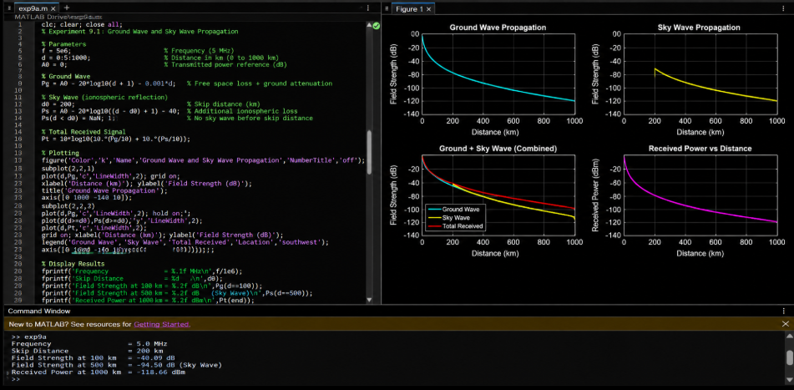

---------------------------------------------------------------------------------------------------------------------

Exp 9b : Simulation of Space Wave Propagation Characteristics using MATLAB

Code:

clc;
clear;
close all;

%% EXPERIMENT 9b
% Simulation of Space Wave Propagation Characteristics using MATLAB

%% Objective 1: Space Wave Propagation

f = 900; % Frequency (MHz)
Pt = 30; % Transmit Power (dBm)
d = 1:1:100; % Distance (km)

% Free Space Path Loss
FSPL = 32.44 + 20*log10(f) + 20*log10(d);

% Received Power
Pr = Pt - FSPL;

%% Objective 2: LOS and Radio Horizon

ht = 50; % Transmitter Height (m)
hr = 25; % Receiver Height (m)

% Radio Horizon Distance
dh_tx = 4.12*sqrt(ht);
dh_rx = 4.12*sqrt(hr);

% LOS Communication Range
d_LOS = 4.12*(sqrt(ht) + sqrt(hr));

%% Objective 3: Link Budget Analysis

Gt = 10; % Transmitter Gain (dB)
Gr = 8; % Receiver Gain (dB)

% Received Power using Link Budget
Pr_link = Pt + Gt + Gr - FSPL;

%% Display Results

fprintf('\nSPACE WAVE PROPAGATION ANALYSIS\n');
fprintf('---------------------------------\n');

fprintf('Operating Frequency = %.0f MHz\n',f);
fprintf('Transmitted Power = %.2f dBm\n',Pt);
fprintf('LOS Distance = %.2f km\n',d_LOS);
fprintf('Radio Horizon of Transmitter = %.2f km\n',dh_tx);
fprintf('Radio Horizon of Receiver = %.2f km\n',dh_rx);
fprintf('Received Power at 10 km = %.2f dBm\n',Pr(10));

%% Plot Results

figure('Name','Space Wave Propagation Characteristics', ...
'NumberTitle','off');

% Graph 1: Free Space Path Loss
subplot(2,2,1);
plot(d,FSPL,'LineWidth',2);
grid on;
xlabel('Distance (km)');
ylabel('FSPL (dB)');
title('Free Space Path Loss');

% Graph 2: Received Power
subplot(2,2,2);
plot(d,Pr,'LineWidth',2);
grid on;
xlabel('Distance (km)');
ylabel('Received Power (dBm)');
title('Received Power vs Distance');

% Graph 3: LOS Communication Range
subplot(2,2,3);
bar(d_LOS);
grid on;
title('LOS Communication Range');
ylabel('Distance (km)');
set(gca,'XTickLabel',{'LOS Range'});

% Graph 4: Link Budget Analysis
subplot(2,2,4);
plot(d,Pr_link,'LineWidth',2);
grid on;
xlabel('Distance (km)');
ylabel('Power (dBm)');
title('Link Budget Analysis');

fprintf('\nSimulation completed successfully.\n');

Output:

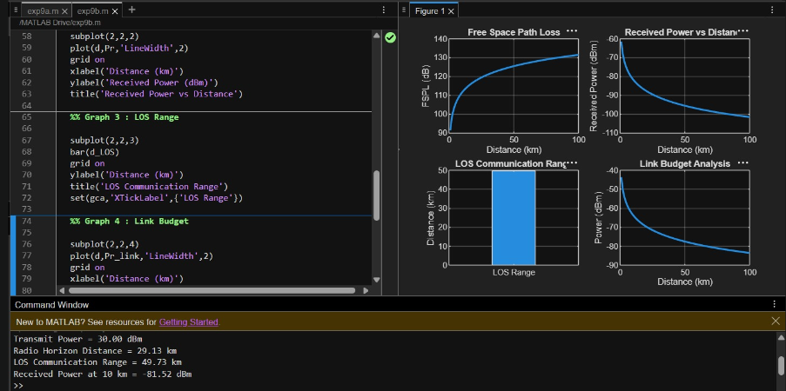

Model Graph:

